Text Comparator Tool

Prepared By,
Ranjith Princy.

Instructions to use the Text Comparator Tool:

1. Copy and paste a passage from the source document into the "Expected" field box.
2. Copy and paste a passage which needs to be tested into "Actual" Field box.

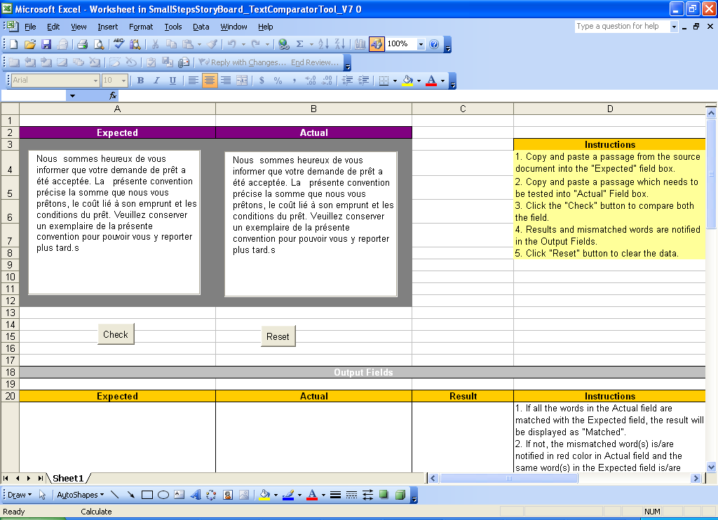

3. Click the "Check" button to compare both the field.
4. Results and mismatched words are notified in the Output Fields.
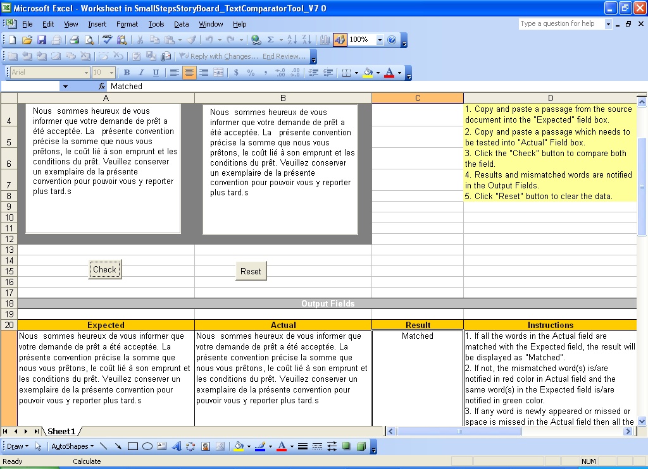

5. Click "Reset" button to clear the data.

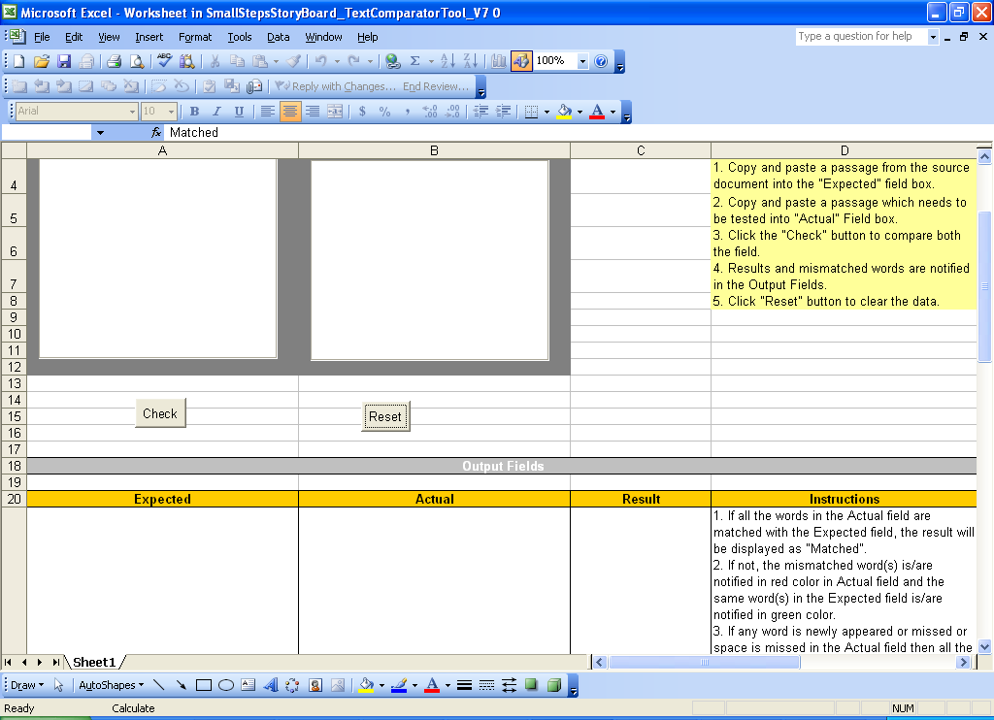

Results :

1. If all the words in the Actual field are matched with the Expected field, the result will be displayed as "Matched".

2. If not, the mismatched word(s) is/are notified in red color in Actual field and the same word(s) in the Expected field is/are notified in green color.

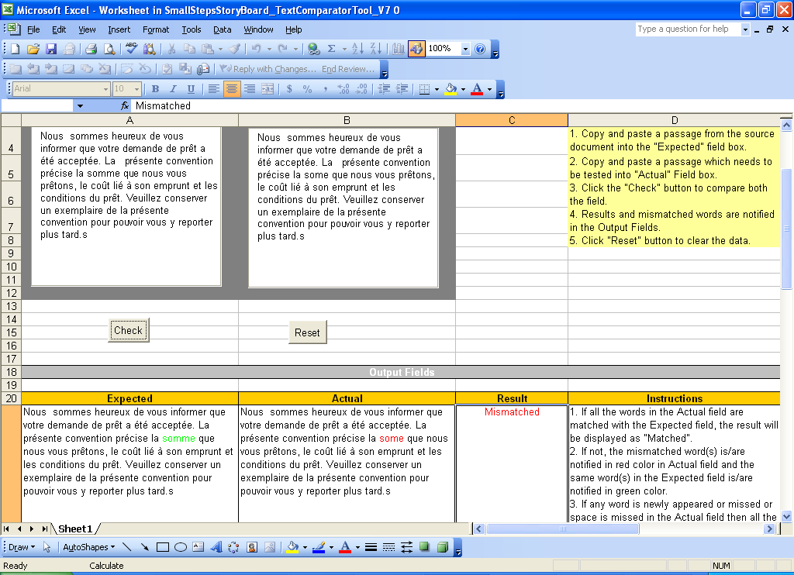

3. If any word is newly appeared or missed or space is missed in the Actual field then all the remaining words (till the end) are notified in red color.
In this scenario, you have to fix that error to proceed the text comparison further.
To fix the error, you have to correct the errors only in the "Text boxes". Manual changes in "output field" will not effect in the result.

- The word “Von” is newly appeared
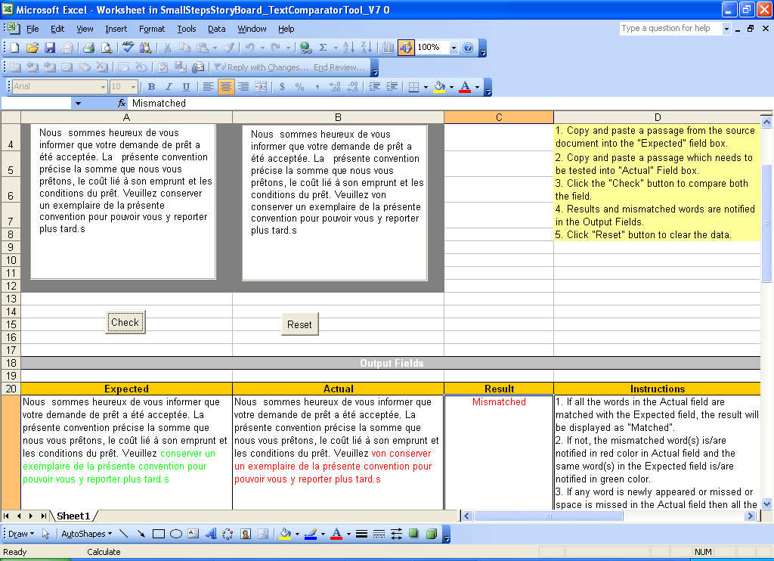

- The Word “conserver” is missed in the Last sentence
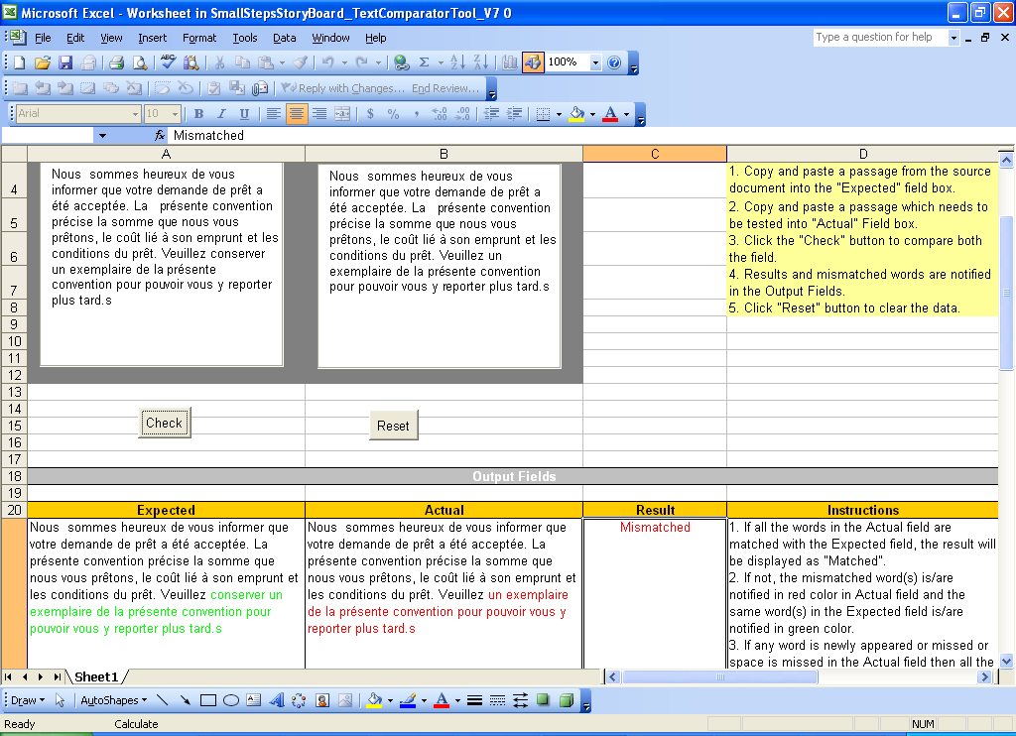

- When the space is missed
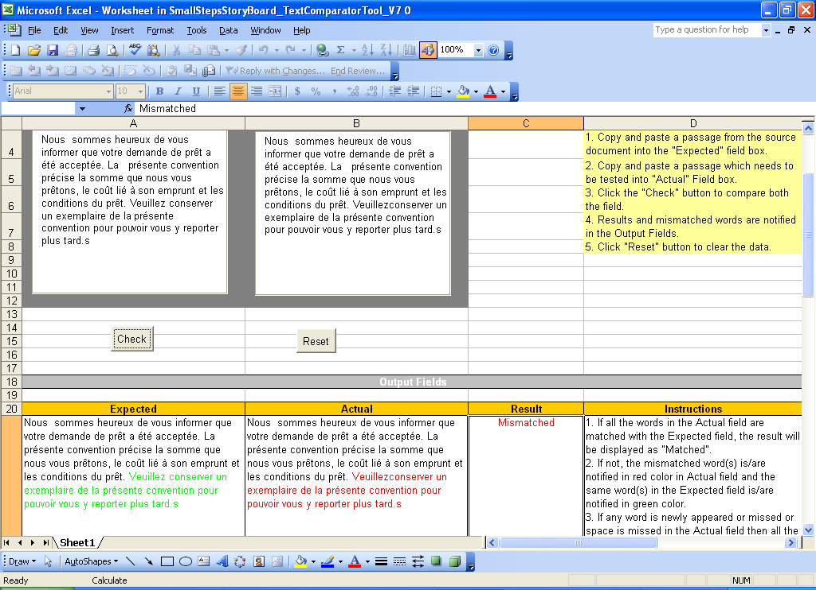

4. If extra spaces appeared in the Actual field, the word before the space is notified in BOLD font format.
